

**Classes Begin: September 17, 2019**

**\*\*Free Orientation: Thursday, August 1, 2019 @ VVC (Bldg. 44)**

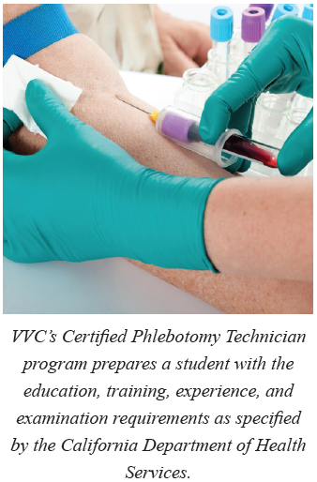

Register at **shop.vvc.edu**

Phlebotomists collect blood samples and units for laboratory tests, transfusions, donations, or research. Phlebotomists who work in medical clinics and hospitals are called Certified Phlebotomy Technicians (CPTs) and generally collect blood samples based on a physician’s order. The blood specimen, once taken, is then sent for diagnostic testing in a laboratory.

(Source: California Employment Development Department Occupational Guide).

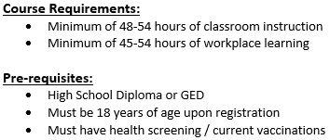

**Course Information**

**Location**: Silverado High School

**Start Date**: 09/17/19 through 01/2020

**Days / Time**: T W Th – 6-9 pm

**Contact**: VVC Community Ed. Department

760-245-4271 ext. 2152

**Tuition: $1,650**

**(Includes background check, uniforms, student ID card, professional liability insurance, course supplies, etc.) Additional fees required. Payment Option available.**

**To register for the free orientation or to enroll, please visit:**

**shop.vvc.edu**